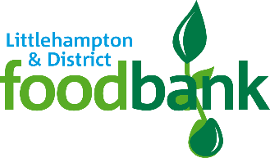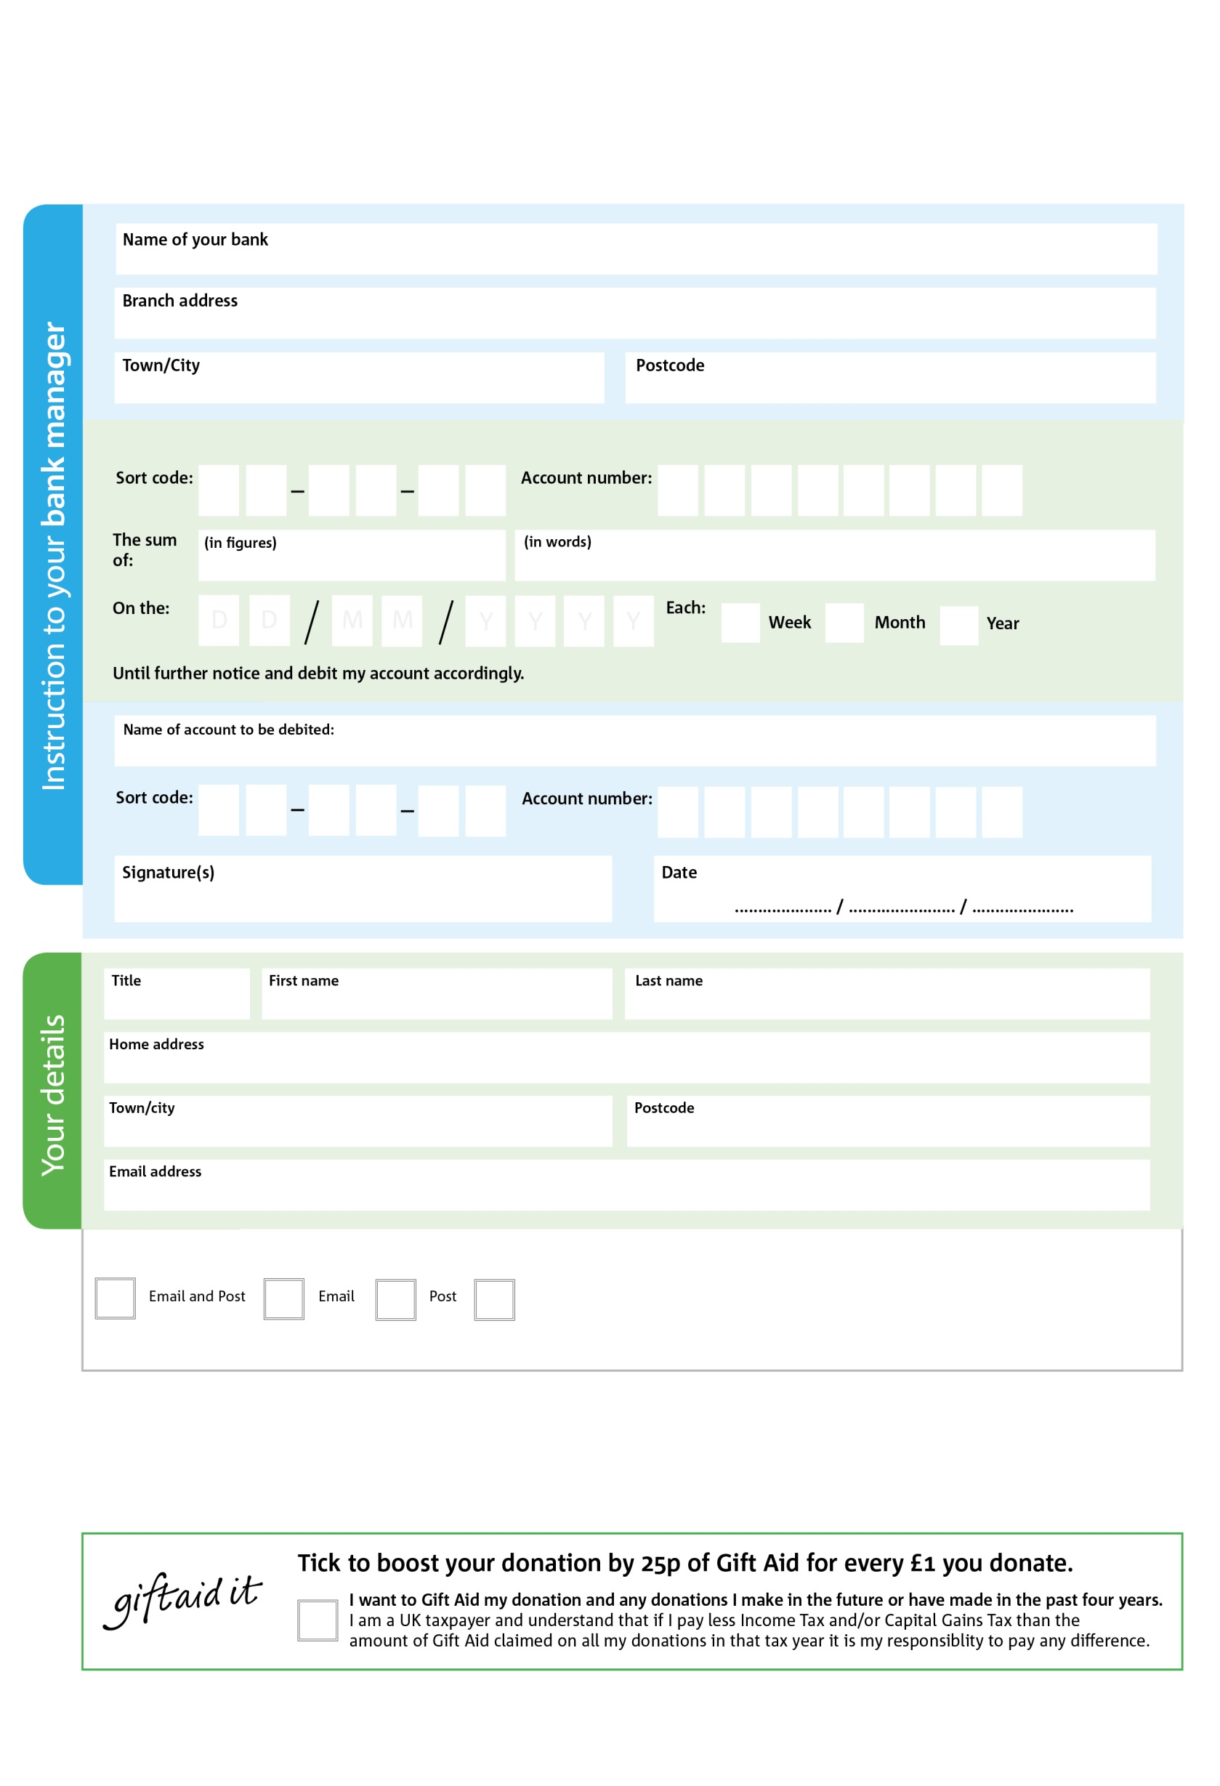

Please pay Littlehampton & District Foodbank,

Registered Charity No: 1160455 | Registered in England & Wales

**Standing Order Mandate**

**littlehamptondistrict.foodbank.org.uk**

POSTAL ADDRESS: Littlehampton & District Foodbank, Littlehampton Baptist Church, Fitzalan Road, Littlehampton, BN17 5NY.

1

V

7

V

6

V

6

V

2

V

0

V

0

V

0

V

**Please pass this form onto the foodbank, using the foodbank’s address at the bottom, who will save a copy for their records.   
They will then send it onto your named bank or building society.**

0

4

2

5

0X

4

We would love to keep you up to date with information about Littlehampton & District Foodbank. Please tick your preference:

You can change your preferences any time by contacting us on 07925 862289 or emailing us at info@littlehamptondistrict.foodbank.org.uk

I do not wish to receive future communications fromLittlehampton & District Foodbank

**Data protection**

*'Littlehampton & District Foodbank is committed to protecting your privacy and will process your personal data in accordance with*

*current Data Protection legislation. Littlehampton & District Foodbank collects information to keep in touch with you and supply you with*

*information relating to our work. To unsubscribe from our newsletter, send a message to the email address above with the word*

*unsubscribe in the subject line. A full data privacy statement for financial donors is available from the foodbank on request.’*

You can change your preferences any time by contacting us on XXXXXXXXXXX or emailing us at XXXX@XXXXXXXXXX.foodbank.org.uk

I do not wish to receive future communications from XXXXXX Foodbank